Exercise: iOS - Creating App with Storyboard
Document Number: |  | Issue Number:  Date:

TABLE OF CONTENTS
1 Exercise 1: Create a very simple iOS application with Resource 2
1.1 Description 2
1.2 Create new Single View Application using storyboard 2
1.3 Application Project was created looks like 4
1.4 Edit MainStoryboard.storyboard. 5
Delete current viewcontroller, add UINavigationController 5
1.5 Add another ViewController to storyboard 6
1.6 Create connection for new view controller. 7
1.7 Create View Controller for Master and Detail View 7
1.8 Create Class for bird-sighting 8
1.9 Create BirdSightingDataController class is subclass of NSObject 10
1.10 Edit Master View Controller 13
1.11 Implement the Master View Controller 13
1.12 Design BirdsDetailViewController as below screenshot 15
1.13 Implement BirdDetailViewController 15
1.14 Send Data to the Detail Scene 16

Exercise 1: Create a very simple iOS application with Resource

Description
The purpose of this exercise is let student understand how to work with Storyboard. Once complete exercise, they know how to create app with Storyboard.

Create new Single View Application using storyboard
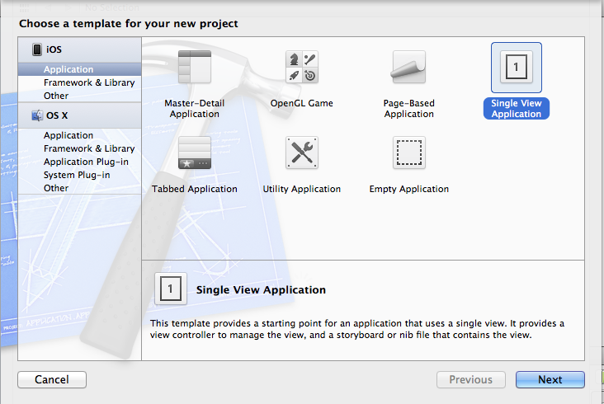

Name Application Name: storyboard and check “Use Storyboards” option
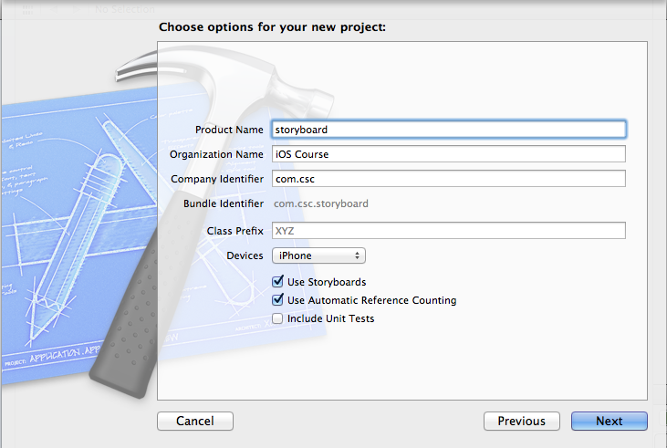

Application Project was created looks like

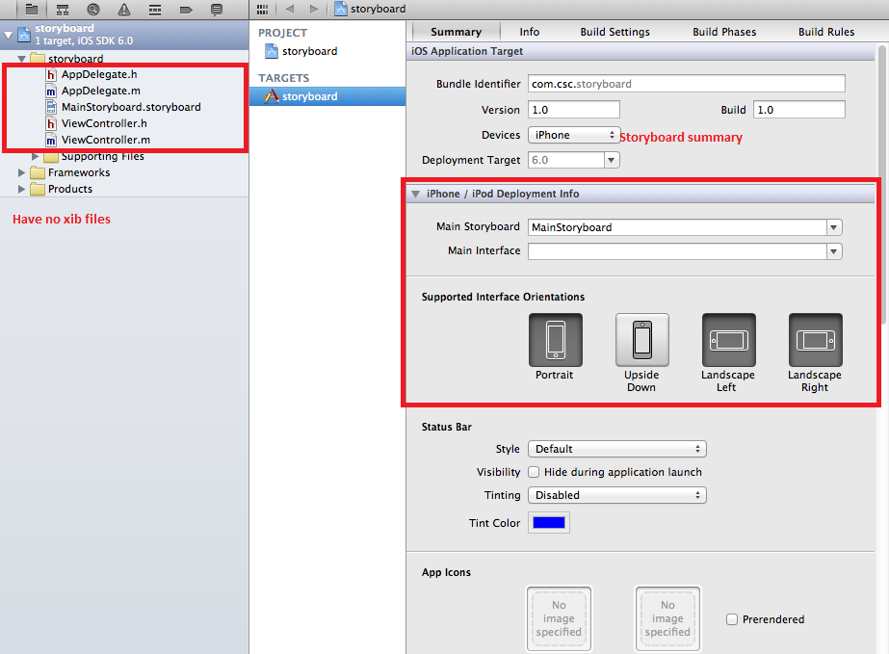

Edit MainStoryboard.storyboard.

Delete current viewcontroller, add UINavigationController

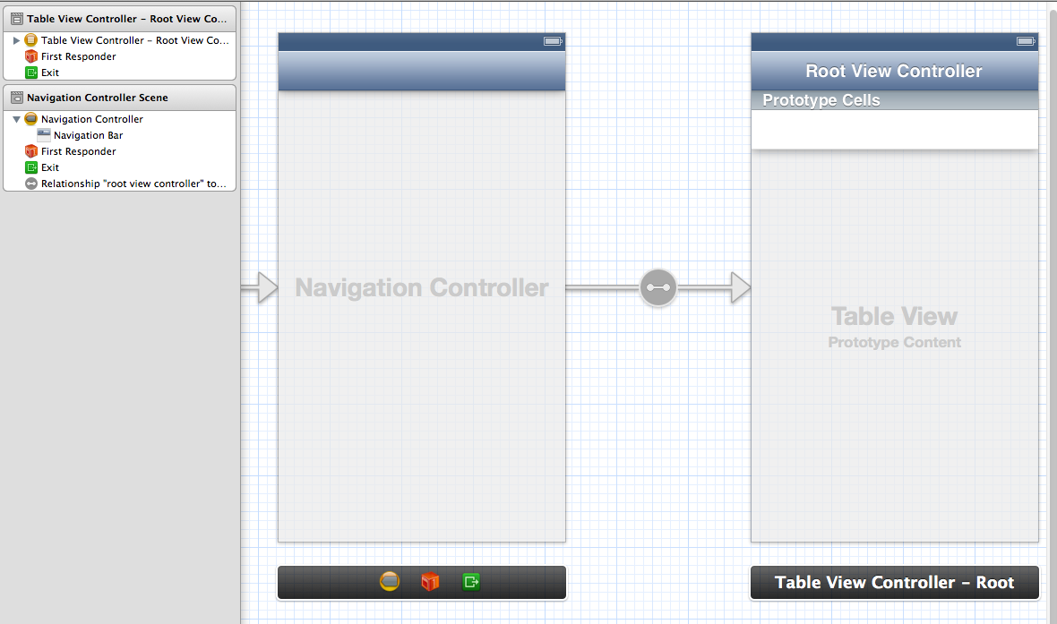

Add another ViewController to storyboard
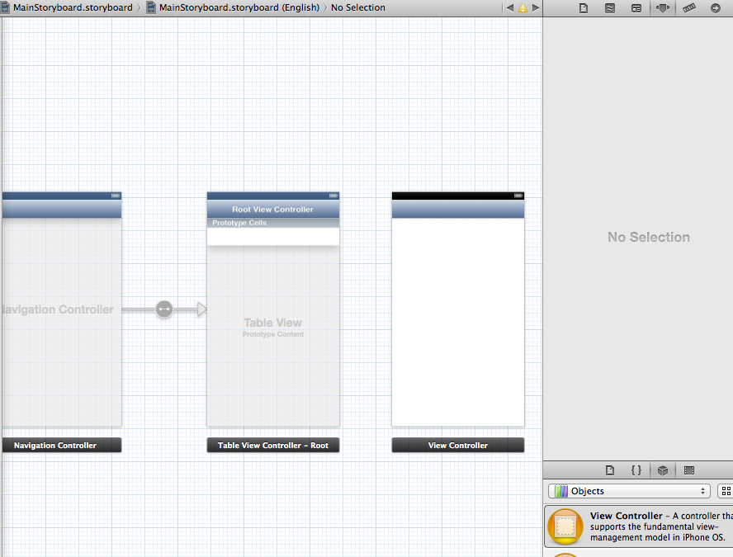

Create connection for new view controller.

Right click

Choose push

Drag to table view controller
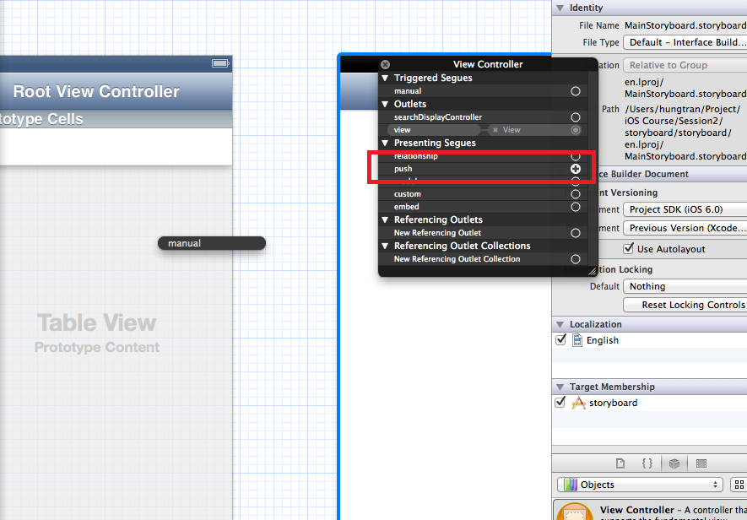

Create View Controller for Master and Detail View
- Create class: BirdsMasterViewController is subclass of UITableViewController
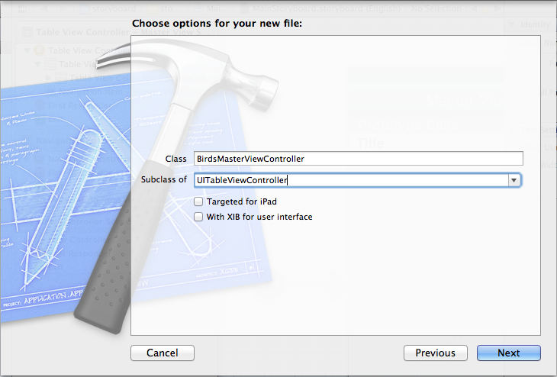
- Similarly, Create class BirdsDetailViewController is subclass of UIView Controller

Create Class for bird-sighting
• In Xcode, choose File > New > File (or press Command-N).
• In the dialog that appears, select Cocoa Touch in the iOS section at the left side of the dialog.
• In the main area of the dialog, select Objective-C class and then click Next.
• In the next pane of the dialog, type the name BirdSighting in the Class field, choose NSObject in the “Subclass of” pop-up menu, and click Next.
By convention, the name of a data object class is a noun because it names the thing that the class represents.
• In the next dialog that appears, choose the BirdWatching folder in the Group pop-up menu:
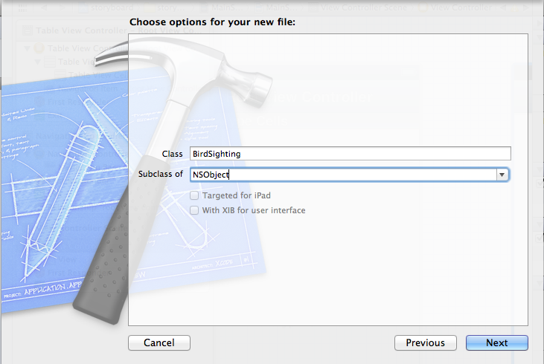
- Edit BirdSighting.h by adding
@property (nonatomic, copy) NSString *name;
@property (nonatomic, copy) NSString *location;
@property (nonatomic, strong) NSDate *date;
-(id)initWithName:(NSString *)name location:(NSString *)location date:(NSDate *)date;
- Edit BirdSighting.m
- (id) initWithName:(NSString *)name location:(NSString *)location date:(NSDate *)date
{
self = [super init];
if (self) {
_name = name;
_location = location;
_date = date;
return self;
}
return nil;
}

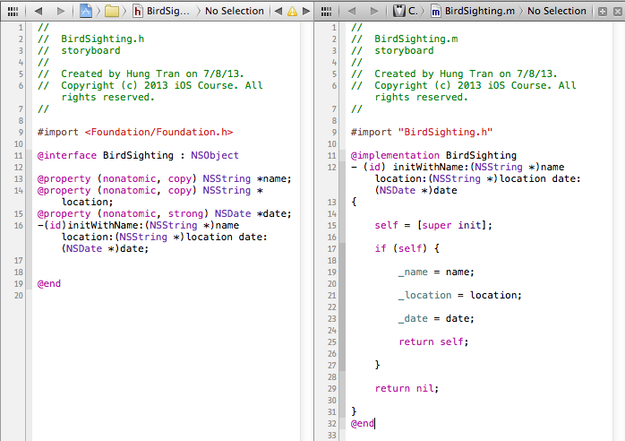

Create BirdSightingDataController class is subclass of NSObject
This class have 3 methods:
- countOfList
- objectInListAtIndex:
- addBirdSightingWithSighting:sighting:

BirdSightingDataController.h
#import <Foundation/Foundation.h>
#import "BirdSighting.h"
@interface BirdSightingDataController : NSObject
@property (nonatomic, copy) NSMutableArray *masterBirdSightingList;

- (NSUInteger)countOfList;

- (BirdSighting *)objectInListAtIndex:(NSUInteger)theIndex;

- (void)addBirdSightingWithSighting:(BirdSighting *)sighting;

@end

BirdSightingDataController.m
#import "BirdSightingDataController.h"

@interface BirdSightingDataController ()

- (void)initializeDefaultDataList;

@end

@implementation BirdSightingDataController

- (void)initializeDefaultDataList {

NSMutableArray *sightingList = [[NSMutableArray alloc] init];

self.masterBirdSightingList = sightingList;

BirdSighting *sighting;

NSDate *today = [NSDate date];

sighting = [[BirdSighting alloc] initWithName:@"Pigeon" location:@"Everywhere" date:today];

[self addBirdSightingWithSighting:sighting];

}

- (void)setMasterBirdSightingList:(NSMutableArray *)newList {

if (_masterBirdSightingList != newList) {

_masterBirdSightingList = [newList mutableCopy];

}

}

- (id)init {

if (self = [super init]) {

[self initializeDefaultDataList];

return self;

}

return nil;

}

- (NSUInteger)countOfList {

return [self.masterBirdSightingList count];

}

- (BirdSighting *)objectInListAtIndex:(NSUInteger)theIndex {

return [self.masterBirdSightingList objectAtIndex:theIndex];

}

- (void)addBirdSightingWithSighting:(BirdSighting *)sighting {

[self.masterBirdSightingList addObject:sighting];

}
@end

Edit Master View Controller
- Open Storyboard file and change style for prototype cell -> Subtitle

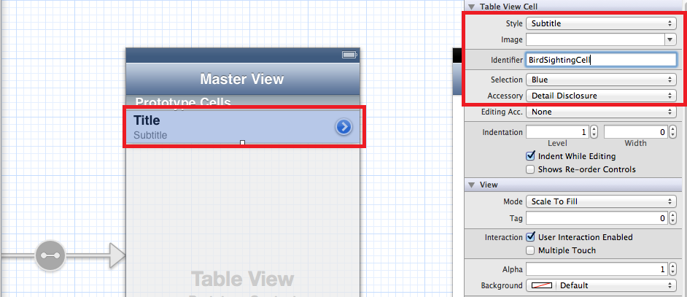

- Change Identifier to: “BirdSightingCell”
- Choose Accessary: Detail
- Change class of TableViewController to BirdsMasterViewController

Implement the Master View Controller
- Declare BirdSightingDataController as property of MasterViewController
BirdsMasterViewController.h
#import <UIKit/UIKit.h>
#import "BirdSightingDataController.h"
@interface BirdsMasterViewController : UITableViewController
@property (strong, nonatomic) BirdSightingDataController *dataController;
@end
Edit BirdsMasterViewController.m
- (void)awakeFromNib

{

[super awakeFromNib];

self.dataController = [[BirdSightingDataController alloc] init];

}
- (NSInteger)numberOfSectionsInTableView:(UITableView *)tableView
{
return [self.dataController countOfList];
}
- (UITableViewCell *)tableView:(UITableView *)tableView cellForRowAtIndexPath:(NSIndexPath *)indexPath
{
static NSString *CellIdentifier = @"BirdSightingCell";
static NSDateFormatter *formatter = nil;

if (formatter == nil) {
formatter = [[NSDateFormatter alloc] init];
[formatter setDateStyle:NSDateFormatterMediumStyle];
}
UITableViewCell *cell = [tableView dequeueReusableCellWithIdentifier:CellIdentifier];
BirdSighting *sightingAtIndex = [self.dataController objectInListAtIndex:indexPath.row];
[[cell textLabel] setText:sightingAtIndex.name];

[[cell detailTextLabel] setText:[formatter stringFromDate:(NSDate *)sightingAtIndex.date]];
return cell;
}

Now, start simulator to see result
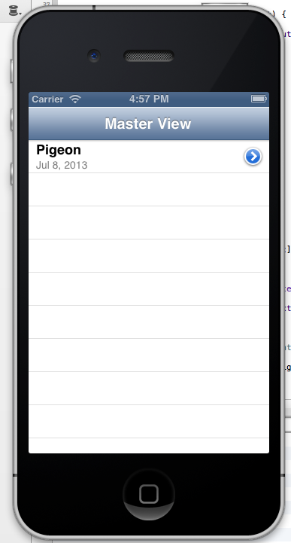

Design BirdsDetailViewController as below screenshot
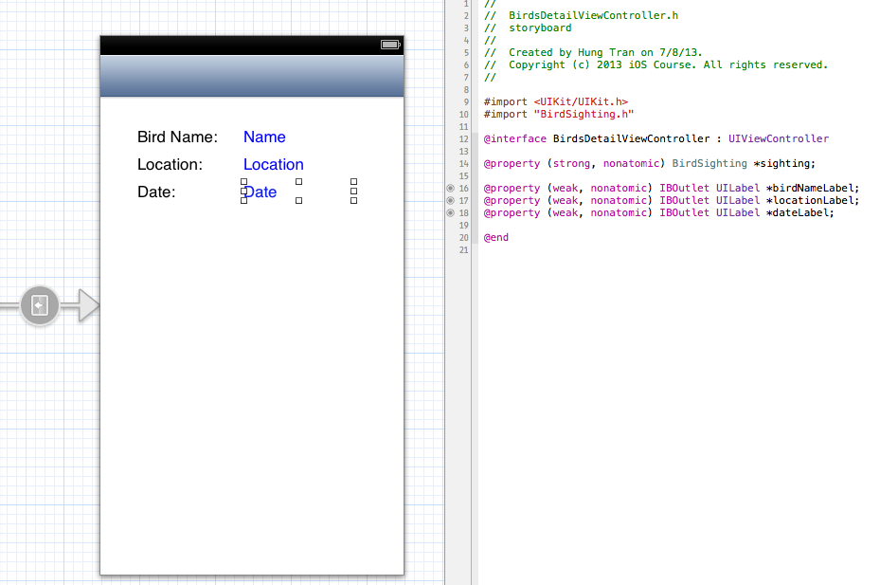

Implement BirdDetailViewController
Add new method configureView and make it be called in viewDidLoad and setSightning method
- (void)configureView
{
// Update the user interface for the detail item.
BirdSighting *theSighting = self.sighting;

static NSDateFormatter *formatter = nil;
if (formatter == nil) {
formatter = [[NSDateFormatter alloc] init];
[formatter setDateStyle:NSDateFormatterMediumStyle];
}
if (theSighting) {
self.birdNameLabel.text = theSighting.name;
self.locationLabel.text = theSighting.location;
self.dateLabel.text = [formatter stringFromDate:(NSDate *)theSighting.date];
}
}

Send Data to the Detail Scene
Set segue identifier from Master to Detail view is “ShowSightingDetails”
Implement this method in BirdMasterViewController

- (void)prepareForSegue:(UIStoryboardSegue *)segue sender:(id)sender

{
if ([[segue identifier] isEqualToString:@"ShowSightingDetails"]) {
BirdsDetailViewController *detailViewController = [segue destinationViewController];

detailViewController.sighting = [self.dataController objectInListAtIndex:[self.tableView indexPathForSelectedRow].row];
}
}

2. Advanced Exercise
Implement by yourself
- Add viewcontroller to add new sightning.
- Use storyboard to connect it to Masterview

